Business Case Template

Document History

|  |  |  |  |
| --- | --- | --- | --- |
| **Revision** | **Date** | **Description of changes** | **Author/Editor** |
| V0.01 | dd/mm/yyy | Document Creation | Paul Keta |
|  |  |  |  |
|  |  |  |  |
|  |  |  |  |
|  |  |  |  |
|  |  |  |  |

Document Owner

|  |  |  |  |
| --- | --- | --- | --- |
| **Name** | **Title** | **Organisation** | **E-mail** |
|  |  |  |  |
|  |  |  |  |
|  |  |  |  |
|  |  |  |  |
|  |  |  |  |

Document Distribution

|  |  |  |  |
| --- | --- | --- | --- |
| **Name** | **Title** | **Organisation** | **E-mail** |
|  |  |  |  |
|  |  |  |  |
|  |  |  |  |
|  |  |  |  |
|  |  |  |  |
|  |  |  |  |

Table of Contents

1 Document Purpose 4

2 Digital City Project Description 4

2.1 Description of Digital City project 4

3 Detailed Project Description 6

3.1 Project Objectives and High Level Scope 6

3.1.1 Project objectives: 6

3.1.2 Project Scope Statement: 6

3.1.3 Deliverables in scope: 7

3.1.4 Deliverables out of Scope: 7

3.2 How Project addresses the identified problem 7

3.3 Description of Location of the Project 7

4 Project Rationale 8

4.1 Description of the Opportunity 8

4.2 Opportunity Cost of Not Implementing 8

5 Alignment of Project to Strategies of [Client] 9

6 Project Benefits 10

6.1 Non-Financial Benefits 10

6.2 Financial Benefits 10

7 Project Finances 12

7.1 Capital Required 12

7.2 Capex 12

7.3 Opex 13

7.4 Total Costs 13

7.5 Cash Flow Projections Summary – Maximum 5 years 13

7.6 Key Assumptions 14

7.7 Source(s) of Investment 14

8 Project Risk Classification 15

9 High Level Milestones 15

10 Additional Information 15

11 Acceptance / Signoff 16

12 Appendix A 17

12.1 Glossary of Terms 17

12.2 Detailed Cash Flow Projections 17

12.3 Project Risk Classification 18

12.3.1 Risk Classification Procedure 18

12.3.2 To carry out risks classification: 18

12.3.3 Risk classification for Digital City Project 18

# Document Purpose

[outline the project’s purpose and a summary of the major work to be done]

The purpose of this business case is to present a cost-benefit analysis that will assist [CLIENT] management with investment appraisal decisions for Digital City Project. The calculated NPV of implementing the Digital City project is estimated to be **R369** million over a five year period

The [Client] is in the process of implementing the [Client]’s Turn-Around Plan, aimed at addressing [Client] management, finance and service delivery problems. As part of the [CLIENT] and as a result of various strategic conversations a number of Projects/programmes were identified, one of them being the Digital City project.

[Client]’s Digital City project is aimed at implementing broadband communication systems and the relevant ICT systems for use by government departments, citizens and businesses in the Metro. Digital City creates electronic communication between the citizens and the [Client]. This implementation is expected to improve economic growth in the City, improve service delivery,position the city as being customer centric as well as improve access to information and services. This undertaking is planned to be achieved within a time period ending May 2016, based on a rollout plan indicated in Section 9 of this document.

# Digital City Project Description

## Description of Digital City project

[Describe the project in a clear way that makes sense to the reader]

A Digital City is an *intelligent technology infrastructure and systems* that enables ubiquitous connectivity to transform key government processes internally and across departments.

[Client] Digital City Project is a connected Urban Development undertaking that is going to be leveraging the current broadband Infrastructure (both Optic Fiber and Wireless Networks) and IT Systems. The project aims to roll-out intelligent technology infrastructure and systems throughout [Client] Metrothat will:

* + 1. Enable global connectivity internally within [CLIENT]
    2. Enable global connectivity externally to Citizens and businesses

The ICT infrastructure focus area as per the [strategy] is aimed at:

* Creating a fibre and wireless network throughout [Client] to create a connected city
* Create internet zones to the public to encourage economic development, especially in historically disadvantaged areas
* Connect all the [CLIENT] buildings and as such increase efficiency
* Install video conferencing in boardrooms and meeting rooms to increase efficiency and reduce travelling time
* Install application functionality to have an increased engagement with the citizens by means of easy-to-use and advanced technology. These include SMS, smart phone, web site and other electronic communication

Digital City Flagship is based on the architecture framework shown below;-[simply with architecture]

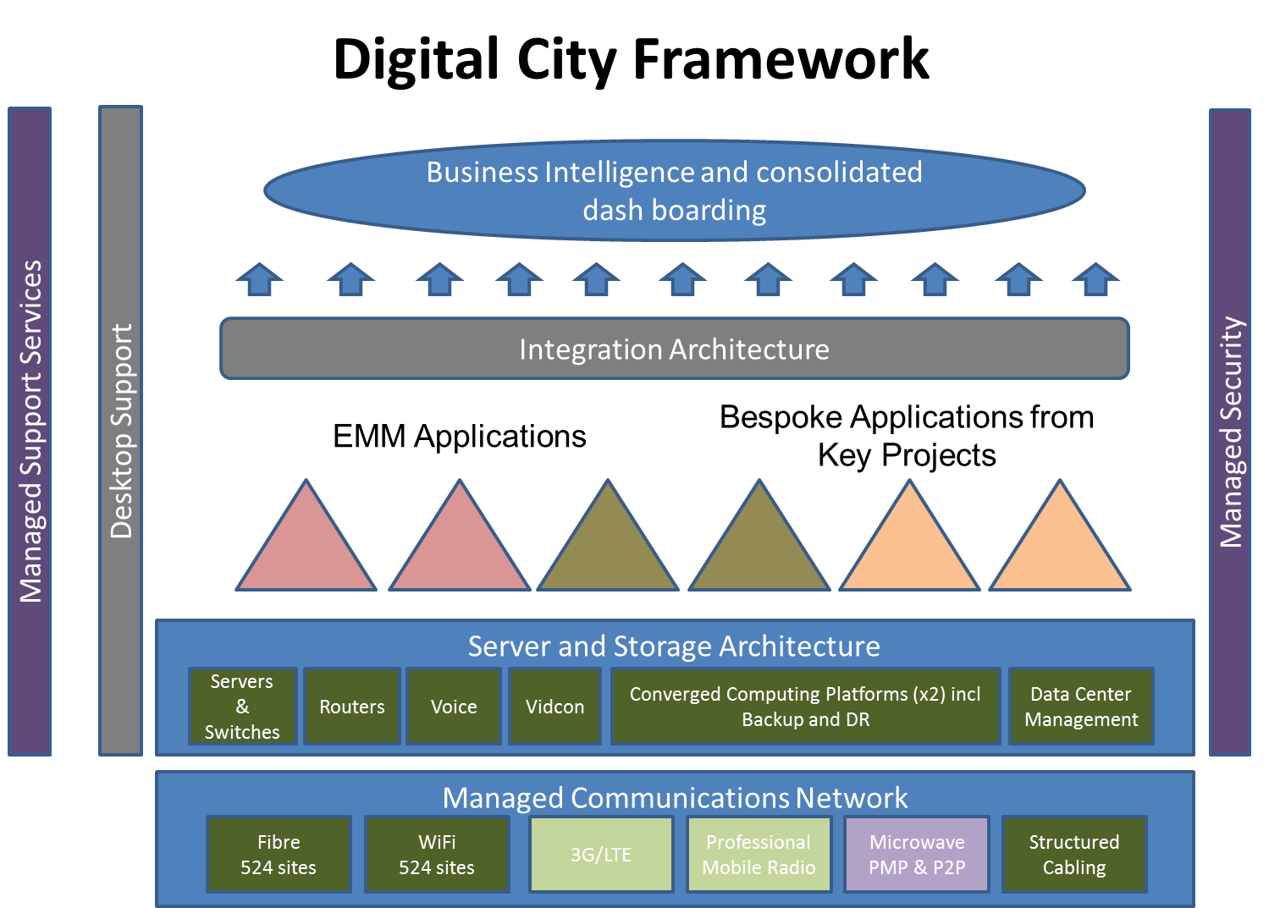

# Detailed Project Description

[objectives and scope including deliverables go hand in hand]

## Project Objectives and High Level Scope

### Project objectives:

Objectives of Digital City Project are categorized under four project streams as below

|  |  |  |
| --- | --- | --- |
| **Stream** | **Stream Name** | **Objective(s)** |
| 1 | Broadband Fiber | * To allow for 3rd party connectivity opportunities (Broadband Access) * To allow for 3rd party hosting in City environment (Data Centre access) * To be a 3rd party enabler – Business enabler, economic development and proxy job creation |
| 2 | Broadband Wireless | * To provide localised citizen connectivity to walled garden as starting point * To provide free Wi-Fi (minimum service provision on a capped basis) to citizens |
| 3 | Unified Command Centre | * Increased operational efficiency for the city * Citizen – Single point of contact * Implementing intelligent capability on [CLIENT] infrastructure and services management with real time response |
| 4 | [CLIENT] E-Citizen Services | * To provide Systems and Applications that will improve internal efficiencies of the Metro and its Citizens. E.g. Mobility and Transport Management Systems, Building management systems, Smart Grids etc. * To enable integration on the new payment engine, e-learning, e-health, CCTVs etc. (the development and choice of these services will be guided by [CLIENT] Strategic Priorities) |

### Project Scope Statement:

Digital City Project aims at rolling-out intelligent technology infrastructure and systems throughout [Client] Metro that will connect 547 [CLIENT] buildings throughout [Client] City using broadband with extended connectivity to Citizens of the City, business community, other government organisations and departments to enable provisioning of communications and E-Services

### Deliverables in scope:

|  |  |
| --- | --- |
| **Platform layer** | **Deliverable(s)** |
|  |  |
| Applications layer | * An integrated ERP system * Customer self-help facility * Launch of 10 application capabilities per month |
| Processing layer | * Upgraded, virtualized and consolidated servers * Consolidated storage estate * To establish a DR site in Boksburg to serve as an emergency recovery site in the event of a disaster at Germiston Datacentre * An industry standard Datacentre in Germiston * To configure DMZ security which will prevent unauthorised intrusions onto the networks * An established UCC * Network Interface to other Flagships e.g. Aerotropolis, IRPTN |
| Connectivity layer | * 2 internal Wi-Fi units in 2 boardrooms of all smaller buildings (non CCC) and one unit for Wi-Fi to the public on each of the 547 buildings * Video Conferencing in 24 boardrooms used by HoDs * Broadband fiber to all 547 [CLIENT] buildings (estimated 547 buildings) |

### Deliverables out of Scope:

**[be specific to avoid future misunderstandings and disagreements]**

* ICT solutions, products and services that are not included in the above Digital City Project deliverables.
* ICT systems that are specific to other Flagships do not form part of the scope of the Digital City Project

## How Project addresses the identified problem

Problems that are listed in Subsection 3.1 of this document will be resolved as the project delivers solutions that are described in the deliverables Subsection 5.1.3

## Description of Location of the Project

Central Services of Digital City will be based in Germiston and Boksburg Datacentres. Digital services will be provided throughout the Metro using broadband. The rollout is as indicated in Section 9 of this document

# Project Rationale

## Description of the Opportunity

[what prompted this project to come about]

The current service delivery scenario provided by legacy ICT systems is as indicated below:

|  |  |
| --- | --- |
| **Platform Layer** | **Current Scenario** |
| Strategic layer | * No ICT capability to support other flagship programs * Disparate ICT solutions on multiple servers and platforms and managed by different departments |
| Applications layer | * 78 non-integrated systems are in operation * Limited customer self-help functions * Insufficient online functionality to serve customers and support operational efficiency |
| Processing layer | * IBM servers have reached end of life and have limited storage * No proper Disaster Recovery and Business Continuity plans * Germiston and Boksburg data centers do not comply with current standards e.g. no UPS and Air-conditioning * IT security configurations can easily be compromised |
| Connectivity layer | * 400km of broadband fiber connecting only 164 sites * Wi-Fi is only available for HQ and CCCs * 293 sites connected by radio equipment that has reached end of life and is unreliable |

## Opportunity Cost of Not Implementing

[what will happen to the business if this project is not implemented]

If the Digital City Project is not implemented then [CLIENT] will continue to deliver its services based on old legacy platforms that have reached end of life. The following are possible impacts:

* Operating and Maintenance costs will increase thus increasing total cost of ownership
* Reliability of systems will continue to deteriorate
* IT systems remain vulnerable to increasing threats and attacks
* Economic downturn
* Low Employee morale

# Alignment of Project to Strategies of [Client]

[Clarify as much as possible how this project supports strategic objectives and goals]

Digital City Project is part of the scope of pillar projects in the following approved [CLIENT] strategies

* **IDP (Integrated development plan)**

The IDP is a detailed 5 year plan which is linked to the [Client] budget and service delivery plans.

Integrated development planning (IDP process) is a process through which [Client] prepare a strategic development plan which extends over a five-year period. The [CLIENT] IDP is the principal strategic planning instrument which guides and informs all planning, budgeting, management and decision making processes in the [Client].

Digital City Project is one of the flagship programmes that will be rolled out to support growth and development of the City (state reference). It will provide Internet-based government services that can connect and transform the forementioned government processes, both internally across service departments and externally to residents and businesses.

* **City Management Turnaround Plan of [[date]**

The turn-around plan is a robust [Client] plan to address [Client] management, finance and service delivery problems. The plan seeks to tackle the underlying causes rather than symptoms and is broad and bold enough in scope to address mission-critical issues. The plan involves radical rather than incremental changes and is a rallying tool to expedite administrative and management practices.

The focal point of the turn-around plan is the repositioning of the delivery approach and practices into immediate action orientation. The Digital City is one of the projects that align with the goals aimed at being reached in the above mentioned plan (Turnaround Strategy xxx).

Digital City project rollout is also aligned with Capital Development Plan priority areas in support of other Flagships i.e.

* **IRPTN -** implementation of Mobility and Transport Management System
* **Revenue Enhancement** - implementation of Smart Metering grids

# Project Benefits

## Non-Financial Benefits

|  |  |
| --- | --- |
| **Stream Name** | **Non-Financial Benefit(s)** |
| Broadband Fiber and Wi-Fi | * This will improve economic growth in the City. Citizens and small businesses will benefit from free Wi-Fi throughout the Metro |
| Unified Command Centre | * Improve Service Delivery by centralising Call Centers under CRM. One number for all City related requests, this will position the City as being customer-centric and will improve our response times to service delivery requests |
| Datacenter Hosting | * Consolidated and Optimised server environment i.e. using smaller servers that are replicated and have more power and running multiple operating systems |
| [CLIENT] E-Citizen Services | * Enabling Citizens to access services online * Users can use online applications from smart phones, tablets and laptops. * Minimizing manual paper based processes by automating processes. * Reduce the need to call the call center or physically walk in by availing services 24X7 online on any device. * Balance enquiry, changing contact details, applying for services etc. all will be done on any device! This will improve service delivery and revenue collection by reducing reliance on physical channels. * Improving citizen experience through all interactions |

These benefits will act as catalysts to attract further investments from private sector organizations and other government organizations

## Financial Benefits

[very important as this attracts investors. Show how the monies will be made. Research where possible]

The Digital City Project is envisaged to increase the GDP of the Metro. This will be a result of increased numbers of citizens, business people, tourists and Government officials who will be enticed to use the free Internet and online services of the City. This is a catalytic activity which will attract larger numbers of users over time. In the future, service charges can then be applied for the use of the services so as to recoup the investment.

Further financial benefits include cost saving resulting from reduced manual processing. This, in turn, results in reduced cost per transaction and increased business activity due to improved internet access. Improved security and compliance will also lead to a reduction of fraud and risk costs. Benefits however are realizable in the long term after completion of the project

The following is a list of cost saving benefits that can be converted into financial figures. These figures are estimates based on one year

|  |  |  |
| --- | --- | --- |
| **Value levers** | **Target Benefit (%)** | **Calculated Benefit** |
| Automation | 10% | R13,8 mil |
| Broadband | 10% | R 1 bn |
| DC Hosting costs | 30% | R 14,7 mil |
| Virtualised servers | 60% | R 29 mil |
| Service Management costs | 30% | [xxx] |
| Operations Centre costs | 30% | R 7,6 mil |
| Printing and Stationery costs | 30% | R 4,4 mil |
| Fraud and Risk costs | 10% | R 1,9 mil |
| Travel time & claims | 10% | R 1 mil |

# Project Finances

## Capital Required

[This is a sum up of all the costs into the project]

Digital City Project requires a capital investment of **R 1,6** billionto be spent over a 3 year period from year 2014

Of this amount a total of **R1,3** billion has already been approved for use based on approved vote numbers below. This contributes to **80.5%** of the capital. An additional **R310**million is required to fund build of an ERP system, contributing to the remaining **19,5%** of the capital investment.

## Capex

Total Capital expenditure budget for a three year period is **R** **1,6** billionas broken down below and as provided by ICT department.

|  |  |  |  |  |  |
| --- | --- | --- | --- | --- | --- |
| **Vote\*** | **Project Name** | **2014/15** | **2015/16** | **2016/17** | **Total** |
|  |  |  |  |  |  |
| 1541106044001 | Acquisition of Electronic document Management system | R 4 070 000 | R 4 477 000 | R 4 924 700 | R 13 471 700 |
| 1541106041511 | DCS: Broadband Fiber | R 48 000 000 | R 156 687 500 | R 156 687 500 | R 361 375 000 |
| 1541106041518 | Digital City Services / Services Integrator (Wi-Fi) | R 30 000 000 | R 39 348 000 | R 31 252 000 | R 100 600 000 |
| 1541106041507 | Enterprise Architecture/ Business process management including Document and Records Management | R 12 100 000 | R 241 000 000 | R 133 428 300 | R 386 528 300 |
| New | ERP Phase 1 | R 10 000 000 | R 100 000 000 | R 200 000 000 | R 310 000 000 |
| 1541107024501 | ICT Equipment | R 1 440 000 | R 1 650 000 | R 1 815 000 | R 4 905 000 |
| 1541106041522 | Migration to Next Generation Network (Video conferencing + routers and switches) | R 30 000 000 | R 12 900 000 | R 0 | R 42 900 000 |
| 1541107024502 | Office Furniture | R 468 000 | R 660 000 | R 726 000 | R 1 854 000 |
| 1541106041525 | Security for ICT Infrastructure | R 30 000 000 | R 42 229 000 | R 36 974 500 | R 109 203 500 |
| New - transfer from CRM 1541106041517 | Unified Command Centre | R 22 500 000 | R 45 000 000 | R 35 000 000 | R 102 500 000 |
| 1541106041523 | Upgrade of Data Centers and Disaster Recovery center | R 4 950 000 | R 26 150 000 | R 19 960 000 | R 51 060 000 |
| 1541106041524 | Upgrading aged server equipment | R 35 910 000 | R 32 675 750 | R 32 675 750 | R 101 261 500 |
|  |  | **R 229 438 000** | **R 702 777 250** | **R 653 443 750** | **R 1 585 659 000** |
|  |  |  |  |  |  |

## Opex

[here it’s operational expenditure..what keeps the business running]

Total Operational Expenditure over a five year period is **R1,67** billionas broken down below and as provided by [CLIENT]. Additional costs of **R1, 84** billion have also been provided by [CLIENT]. These amounts are excluded from the initial capital outlay and will be financed by [CLIENT] operating revenues

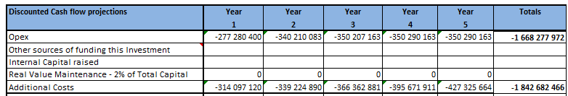

## Total Costs

The total cost over a five year period is **R5,1** billion as indicated below.

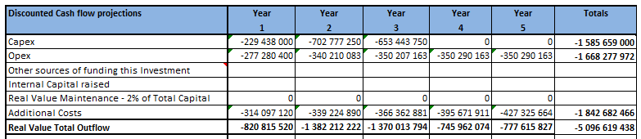

## Cash Flow Projections Summary – Maximum 5 years

[our template calculates the discounted values as well as net present value. Just input the key figures]

Below is a summary of cash flows with a Net Present Value based on discount rate of 15% over a five year period. The discount rate has been provided by [CLIENT] Corporate Finance. The projections make use of Net Present Value technique that seeks to identify the magnitude and timing of all incremental cash flows that arise as a result of a project. These cash flows are then discounted back to a present day value to identify the financial worth of a project.

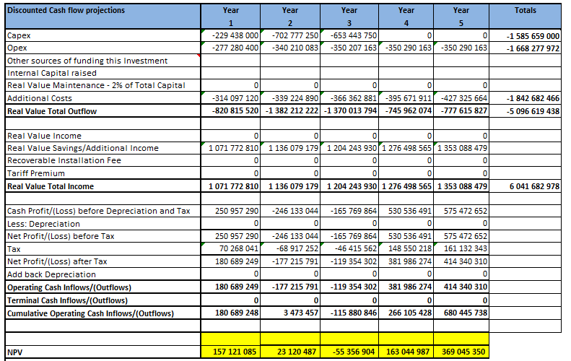

## Key Assumptions

Major assumptions that impact financial cashflow analysis

1. Discount factor (WACC) assumed to be 15% per annum
2. Buy and build combinations applied to broadband deliverable
3. That the project is of a catalytic nature for economic growth
4. That the project requires a once-off intial capital investment
5. That benefits include social benefits for citizens, cost savings and economic growth

## Source(s) of Investment

* Public Private Partnerships
* Government Capital Grants

# Project Risk Classification

This is a medium risk project with risk classification score factor of **11** as in Appendix A

# High Level Milestones

[a project implementation schedule is important. Use Excel or MS project]

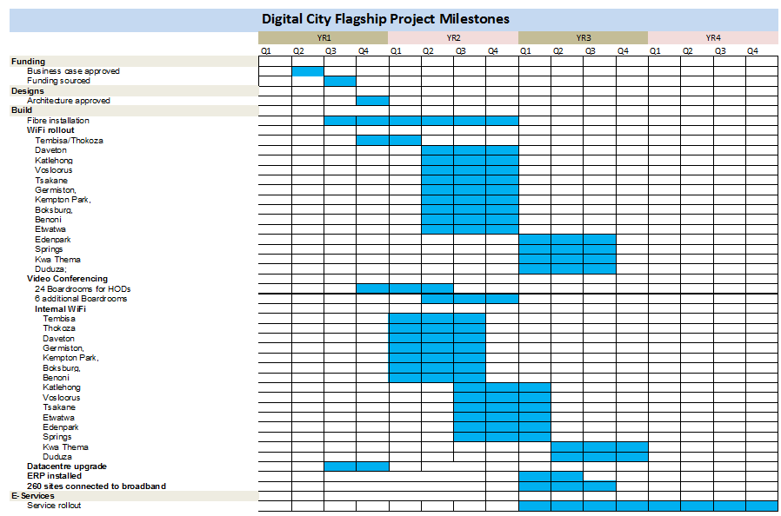

# Additional Information

If you have any questions or comments on this document, please contact:

Paul Keta – Managing Consultant-Team Six Consultants. Email [pketa@team6.co.za](mailto:pketa@team6.co.za)

# Acceptance / Signoff

We have reviewed this business case document and accept that the information contained reflects what we have set out to achieve in this Project

|  |  |
| --- | --- |
| **Prepared by: (Project Lead/Manager – Service Provider)** | |
| **Name:**  **Surname:** |  |
| **Signature** **Date** |
| **Approved By: (Head - [Client]** | |
| **Name:**  **Surname** |  |
| **Signature**  **Date** |
| **Approved By: (Applications Stream Lead - [Client]** | |
| **Name:**  **Surname** |  |
| **Signature**  **Date** |
| **Approved By: (CIO - [Client])** | |
| **Name:**  **Surname** |  |
| **Signature**  **Date** |
| **Approved By: (Other [Client])** | |
| **Name:**  **Surname** |  |
| **Signature** **Date** |
| **Approved By: (HoD PMO - [Client]** | |
| **Name:**  **Surname** |  |
| **Signature**  **Date** |
| **Approved By: (City Management Committee - [Client]** | |
| **Name:**  **Surname** |  |
| **Signature**  **Date** |

# Appendix A

## Glossary of Terms

|  |  |
| --- | --- |
| **Abbreviation** | **Description** |
| Capex | Capital Expenditure |
| CCC | Customer Care Centre |
| CCTV | Close Circuit Television |
| CRM | Customer Relationship Management |
| DH | Divisional Head |
| DMZ | Demilitarized Zone |
| [CLIENT] | [Client] Metropolitan [Client] |
| [CLIENT]TP | [Client] [Client] Turnaround Plan |
| EPMO | Enterprise Project Management Office |
| ERP | Enterprise Resource Planning |
| GDP | Gross Domestic Product |
| GDS | Growth and Development Strategy |
| HoD | Head of Department |
| HQ | Head Quarters |
| ICT | Information and Communication Technology |
| IDP | Integrated Development Plan |
| IRPTN | Integrated Rapid Public Transport Network |
| NPV | Net Present Value |
| Opex | Operational Expenditure |
| PMO | Project Management Office |
| UCC | Unified Command Centre |
| UPS | Uninterruptible Power Supply |
| WACC | Weighted Average Cost of Capital |

## Detailed Cash Flow Projections

Refer to the attached Excel financial spreadsheet

## Project Risk Classification

### Risk Classification Procedure

To determine the Risk classification, a project is assessed against five risk categories

* Size
* Complexity
* Time-scale
* Business Impact
* Organisation

The risk categories are further subdivided into specific risk factors.

Within each risk factor there are three risk ratings – 1, 2 or 3. The ratings awarded for each factor are averaged to achieve an overall risk rating for the project.

### To carry out risks classification:

1. Score each risk factor using the risk ratings indicated in Table 2.
2. Add the scores for each risk category.
3. Total the ratings to give a maximum project score of 15
4. Classify the risk according to total score ass follows

* High Risk = score of 12-15
* Medium Risk -= score of 7 - 11
* Low Risk = score of <7

### Risk classification for Digital City Project

|  |  |
| --- | --- |
| **Risk Score (max score 15)** | 11 |
| **Risk Classification (High Medium Low)** | Medium |
| **Is this a Critical Project? (Yes, No)** | Yes |

|  |  |  |  |  |  |
| --- | --- | --- | --- | --- | --- |
| **Risk Category** | **Risk Factor** | **Notes** | **Factor Score** | **Category total** | **Rounded Average** |
| **Project Size** | Cost |  | 3 |  | |
|  | Project duration |  | 3 | 3 | 3 |
| **Complexity** | Project objectives |  | 2 |  | |
|  | [CLIENT] areas impacted |  | 2 |  | |
|  | External parties |  | 2 |  | |
|  | Degree of change |  | 2 |  | |
|  | Dependence on other projects |  | 2 | 2 | 2 |
| **Time-scale** | Ability to achieve |  | 1 |  | |
|  | End-date |  | 2 | 1.5 | 2 |
| **Business Impact** | Impact on Annual Results |  | 2 |  | |
|  | Strategic significance |  | 3 |  | |
|  | Customer impact |  | 3 |  | |
|  | Regulatory impact |  | 2 |  | |
|  | Market impact |  | 3 |  | |
|  | Reputation |  | 3 |  | |
|  | Stability of local environment in which the project is operating |  | 2 | 2.57 | 3 |
| **Organisation** | [CLIENT] group experience |  | 1 |  | |
|  | Team experience |  | 1 |  | |
|  | Technology risk |  | 1 |  | |
|  | Business risk |  | 1 | 1 | 1 |
| **TOTAL** | | | | **10.07** | **11** |

|  |  |  |  |  |
| --- | --- | --- | --- | --- |
| **Risk Category** | **Risk Factor** | **Rating 1** | **Rating 2** | **Rating 3** |
| **Project Size** | Cost | <R100m | <R100m to R1b | >R1b |
|  | Project duration (including Feasibility) | <6mths | <12mths | >=12mths |
| **Complexity** | Project objectives | Detailed scope clearly understood and agreed | High level scope understood and agreed | Scope not yet agreed |
|  | [CLIENT] areas impacted | Single business unit and single geography | Multiple business units or multiple geography | Multiple business units and multiple geography |
|  | External parties | No external supplier involved | 1 external supplier involved | Significant involvement of >1 external supplier |
|  | Degree of change | No operational change | Minor operational changes | Major operational changes |
|  | Dependence on other projects | Single, self-contained project | Dependence on one other project | Dependence on multiple projects |
| **Time-scale** | Achievability | Confident in both time-scale and likely level of contingency | Demanding – time-scale may have insufficient contingency | Very demanding – time-scale is very tight and has no contingency |
|  | End-date | Not imposed | Imposed internally | Imposed externally |
| **Business Impact** | Impact on Group Annual Results - results materially affected by: | <0.1% | <0.5% | >=0.5% |
|  | Strategic significance | Minimal | Moderate | Significant |
|  | Customer impact | Minimal | Moderate | Significant |
|  | Regulatory impact | Minimal | Some negotiations required with one or more regulators | Significant negotiations with one or more regulators |
|  | Market impact | No + or - impact on share price | Moderate + or - impact on share price | Significant + or - impact on share price |
|  | Effect (+ or -) on reputation | Minimal | Moderate | Significant |
|  | Stability of local environment in which the project is operating | Stable | Moderate degree of instability | Unstable |
| **Organisation** | [CLIENT] Group experience | Done before | 1st time in business unit or geography | 1st time in Group |
|  | Team experience | Project management and team skills available within business unit or geography | Project management and team skills available within Group (but not in business unit or geography) | Project management and team skills in scarce supply |
|  | Technology risk | Familiar technology | Technology new to business unit or geography | Technology new to Group |
|  | Business risk | Familiar business process/product | Business process/product new to business unit or geography | Business process/product new to Group |